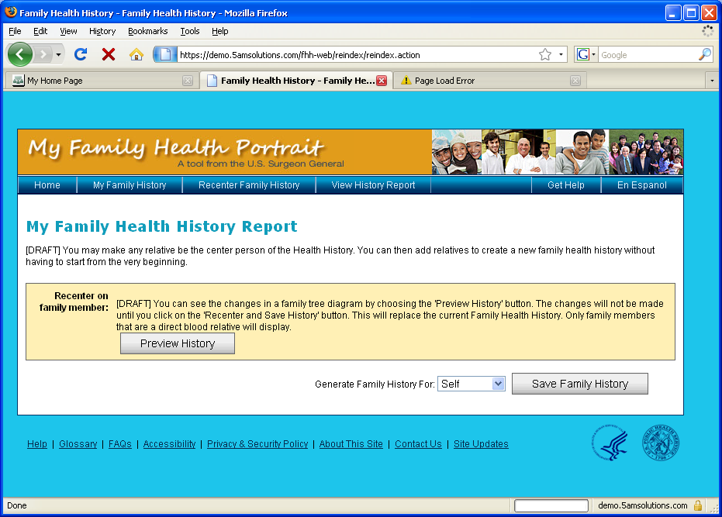

Copy for Family Member Help
You can copy your health history for a family member. By making this copy, your information appears as though the family member you chose is the focus.
This makes it so your family does not have to enter health history again and can easily add information to what you have entered.

On this page you can:
- Select the family member that you would like to copy this for from the drop-down box.
- Click ‘View History’ to see what the health history will look like for the family member that you chose. The new health history will show the family member you selected as the focus of the family history.
- Click ‘Save Family History’ to save the health history to your local computer or personal storage device.

